

**CALL CENTER SOLUTION – AMAZON CONNECT**

**Enterprise Integration Technology**

Sarvan Veluppillai

Zikora Orakwe

Ammar Ahmad

Jing Yu

**TABLE OF CONTENTS**

**Revision History 3**

**Executive Summary 4**

**Prerequisites 4**

**Project Objectives 4**

**Project Timeline 5**

**Stakeholders 5**

**Cloud Architecture 6**

*Deployment Strategy 8*

*Security and Compliance 8*

*Infrastructure Provisioning 9*

*Deploy and Validate a Contact Center 10*

1. Contact Center Deployment 10

2. Claim a Number and Quickly Validate the Deployment 12

3. Amazon Connect UI Overview 16

4. Introduction to Flows. 17

**Conclusion 24**

# **Revision History**

The following revisions identify major changes to this document:

Table 1:

| DATE | REVISED BY | VERSION | REVISION DETAILS & REFERENCE |
| --- | --- | --- | --- |
| Nov 13, 2023 | Sarvan Veluppillai | 001 | Document Creation |
| Nov 14, 2023 | Zikora Orakwe  Ammar  Jing Yu | 001 | Contributors |

# **Executive Summary**

Through the implementation of Amazon Connect and AWS, customer Call Center at GroupOne bank has significantly enhanced customer service.

This has resulted in faster routing of calls to the appropriate personnel, empowering agents with advanced tools. Introducing features such as call forwarding and a call-back option has further streamlined operations, contributing to an improved overall experience. These enhancements align with our commitment to delivering high-quality banking services, ensuring enhanced efficiency for all stakeholders involved.

# **Prerequisites**

**AWS Account**

AWS Account is required for this workshop. Your account must have the ability to create new IAM roles and scope other IAM permissions.

**AWS Region**

This workshop is designed to be completed in any region where Amazon Connect service is available.

**AWS Skills and Experience**

This workshop is intended as an introduction to Amazon Connect. The content of this workshop is aimed at enabling users with no previous knowledge of AWS services or Amazon Connect

**Lab Materials**

Please download the [**Lab_Files**](https://static.us-east-1.prod.workshops.aws/public/130173f1-b18a-444b-8602-7e7c0d46f18f/static/Lab_Files.zip) archive file which is required for completion of this workshop.

# Project Objectives

**Efficient Call Handling:**

* Ensure swift, secure, and efficient routing of calls to designated agents.

**Call Recordings:**

* Record calls for quality assurance and other pertinent data processing purposes.

**Voice Response:**

* Implement a dynamic voice response system to guide customers in selecting the appropriate agent.

**Agent Management:**

* Equip agents with enhanced tools to efficiently assist customers.

**Integrations (Lambda, Amazon Lex):**

* Enable the seamless triggering of serverless functions during contact flows.
* Ensure customers receive responsive and effective chat interactions through Amazon Lex.

**Monitoring:**

* Real-time monitoring of contact center performance for proactive management.

**Security Measures:**

* Implement Access Control to manage permissions for users and administrators.

**Customer Engagement:**

* Facilitate customer engagement by enabling call-back options and connecting them with relevant agents.

# Project Timeline

* Project Initiation (1 Week)
* Requirement Gathering (1 Week)
* Design and Development (1 Month)
* Testing For Quality Assurance (2 Weeks)

# Stakeholders

* Executive Leadership (CEO, COO , CIO)
* IT Department
* Human Resources
* Consultants
* Customers
* Vendors and Partners
* Legal Department

**Implementation Team:**

* Project Manager - Sarvan Veluppillai
* Cloud Architect - Zikora Orakwe
* Developers - Ammar Ahman
* AWS Account Manager - Jing Yu

# Cloud Architecture

|  |  |
| --- | --- |
| Services that will be used for this implementation: | *Features that will be implemented:* |
| * Amazon Lambda. * Amazon DynamoDB. * Amazon Lex. * Amazon Connect. * Amazon S3 Bucket. | * Customer experiences across voice and chat. * IVR/Menu allocation. * Authentication process. * Text to speech approach. * Hours of operation. * Call back feature. * Skill, priority, and Attribute based routing. * Amazon LEX AI. * Amazon LEX hand off to Connect. * Logging. |

Architectural Diagram:

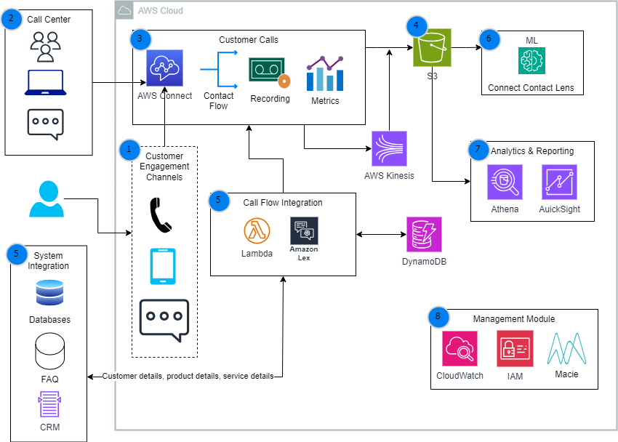

Diagram Details:

|  |  |
| --- | --- |
|  | The GroupOne Banking customers connect with service teams using either their phone or chat feature, initiating a call or chat session on Amazon Connect. |
|  | Customer Contact Center receives Incoming/outgoing calls to/from Customers. These calls go to the agent queues. There are multiple agents will be working on their own queue. They will be using various devices and channels to service those customers. |
|  | The Amazon Connect instance captures the call details, including contact flow, call recordings, and metrics. |
|  | Call details, including recordings, are stored in Amazon Simple Storage Service (Amazon S3). Amazon Kinesis prepares, redacts, or encrypts any sensitive information or personally identifiable information (PII) before storing in Amazon S3. |
|  | Call flow integrations use AWS Lambda, and Amazon Lex. These services invoke event related processes and data dips with multiple source systems, or databases, to check the customer related information, product details, customer interaction history, and transaction history. Amazon Lex enables to build natural language bots. This can be integrated within mobile application, web application, and chat platforms. |
|  | Amazon Connect Contact Lens provides Realtime analytics of customer sentiment and their conversation using machine learning (ML) |
|  | Amazon Athena and Amazon QuickSight provide data analytics on the details from the stored calls. |
|  | Amazon CloudWatch, Amazon Macie, and AWS Identity and Access Management (IAM) monitor, scan for PCI or PII information, and secure the customer's data. |
|  |  |

## Deployment Strategy

The deployment strategy involves several phases to ensure a smooth and reliable setup for GroupOne Bank's call center. First, there's testing, where we check if everything works correctly in a safe environment. Once everything looks good, we move to staging, which is like a practice run in a more realistic setting. Finally, there's the production phase, where the actual call center goes live, and agents start using it for real customer interactions. Each phase helps us catch and fix any issues before they affect the live operations, ensuring a successful deployment.

## Security and Compliance

Highlight security measures and compliance standards adhered to during the project.

In general, AWS guarantees the availability of our infrastructure on the cloud to around 99%. However, AWS ensures security of the cloud, and we are responsible for security in the cloud. The security resource that we majorly used in this project is the AWS Identity and Access Management (IAM). Access control and authentication, Network security and monitoring, and Data protection are crucial in the AWS Contact Center Solution.

Access control and authentication are critical components in ensuring the security and compliance of the AWS Contact Center Solution. With robust access control mechanisms in place, organizations can manage and restrict user access to sensitive data and resources, reducing the risk of unauthorized access or data breaches. This includes implementing multi-factor authentication, fine-grained access controls, and identity and access management policies. By enforcing strong authentication protocols, organizations can authenticate user identities and ensure that only authorized individuals can access the contact center solution. Additionally, regular audits and assessments are essential to identify and address any security vulnerabilities or compliance gaps. Through comprehensive training and awareness programs, employees can stay updated on the latest security best practices and guidelines, further bolstering the overall security posture of the AWS Contact Center Solution.

In this project, we used the IAM role which allowed the Lambda function to integrate with DynamoDB granting the required permissions and ensuring the least privilege principle.

Compliance certifications and regulations play a crucial role in ensuring the security and integrity of AWS Contact Center Solution. AWS Contact Center Solution adheres to various compliance certifications and regulations, ensuring data protection and privacy for customers. These certifications and regulations validate AWS's commitment to maintaining a secure and compliant environment. By complying with these standards, AWS Contact Center Solution ensures that customer data is handled in a manner consistent with industry best practices. This includes compliance with regulations such as GDPR, HIPAA, SOC 2, and ISO 27001, among others. In addition to adhering to these certifications and regulations, AWS Contact Center Solution also provides mechanisms and tools to help customers ensure compliance within their own organizations, offering peace of mind and confidence in their contact center solution.

## Infrastructure Provisioning

In this section we will outline the following steps to deploy Contact Centre architecture.

* Deploy and Validate a Contact Center.
  + Contact Center Deployment.
  + Claim a Number and Quickly Validate the Deployment.
  + Amazon Connect UI Overview.
* Introduction to Flows.
  + Introduction to the Contact Flow Library and Sample/Default Flows.
  + Review Contact Flow Blocks.
  + Create A Simple Contact Flow.
  + Test the Contact Flow.
* Creating dynamic, personalized experiences in Amazon Connect.
* Interactive Speech using Amazon Lex.
* Amazon Connect Metrics.

## Deploy and Validate a Contact Center

### Contact Center Deployment

* Select you region.
* Search for service ‘Amazon Connect’.
* Choose ‘Get Stated’ if this is the first instance or ‘Add an instance.’

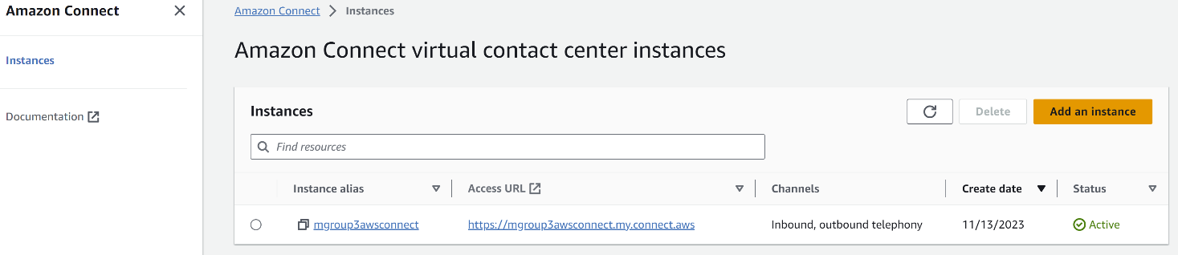

* Under set identity
  + Select Store users within Amazon Connect.
  + Give you instance a name – here ‘grpOne chosen as the instance name.
  + Select ‘Next’.

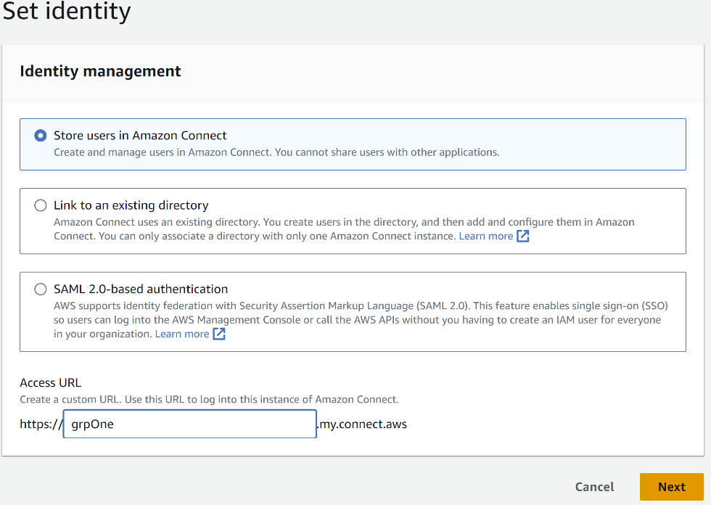

* On the Add Administrator screen, fill out the form to create an administrator and select Next.

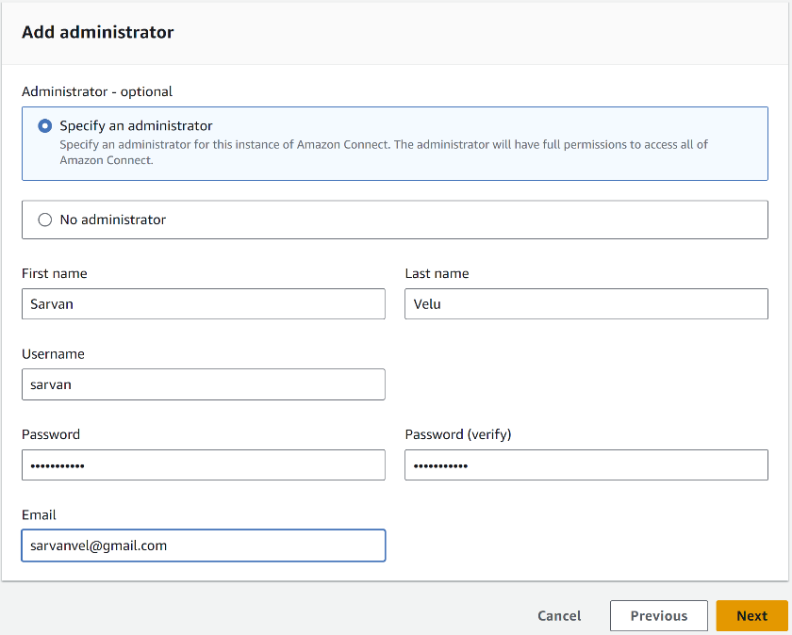

* On the Set Telephony options screen, accept the defaults:
  + Select Allow Incoming calls.
  + Select Allow Outgoing calls.
  + Select Next.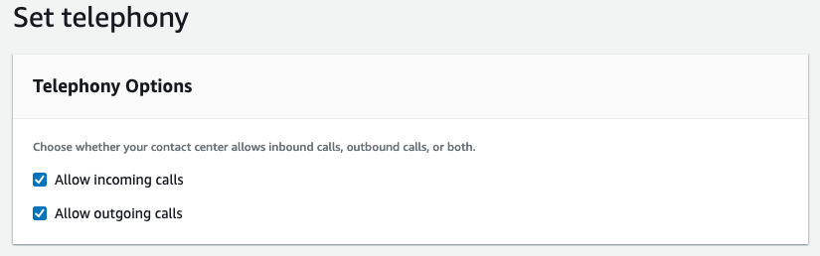
* On the **Data storage screen**, select Default settings and select ‘Next.’
* On the **Review and Create screen**, review your settings, then select **Create instance**.
* Wait for instance creation to complete.
* Once the instance is created, you will see Get Started.

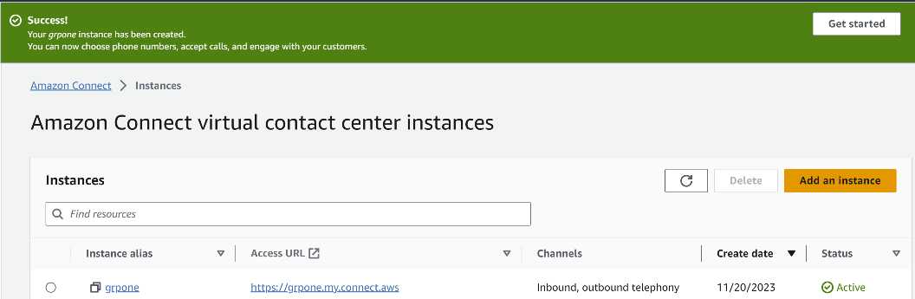

### Claim a Number and Quickly Validate the Deployment

* Select ‘Get Started.’



* On the Welcome to Amazon Connect screen, select Let’s go.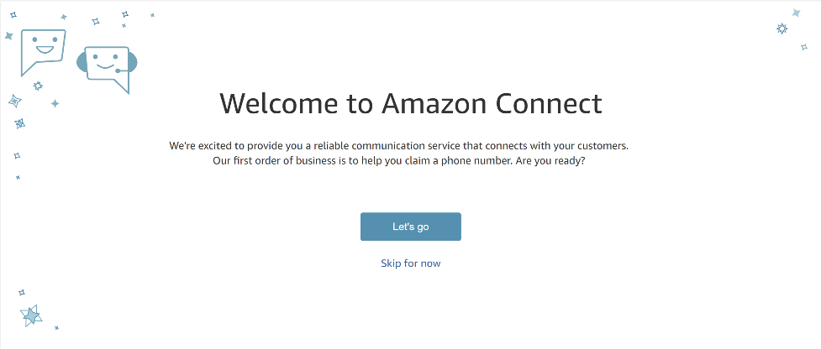
* If you get a prompt for Microphone Access or Notification access, please select Allow for both prompts.
* On the Claim phone number screen:
* From the Country drop down list, select desired country.
* From the Type drop down list, select Toll Free or DID (Direct Inward Dialing) option.
* Pick a phone number from the list and select **Next**.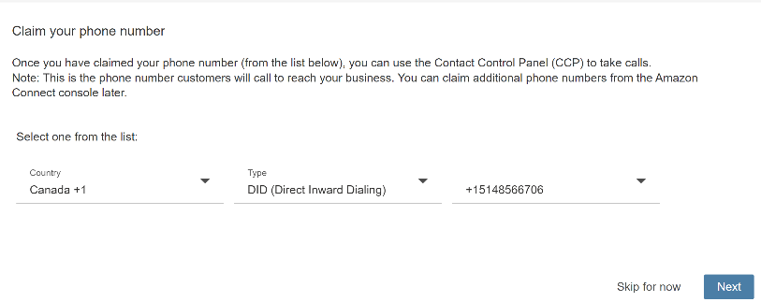
* Perform a test call. If there are any popup asking for ‘Allow’ permission, choose ‘Allow’

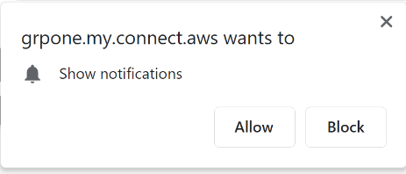

* Select ‘Available’ from the agent menu.

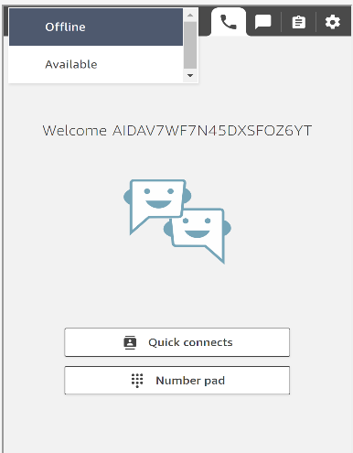

* Now dial the select number using your phone/cell.
* Dial the number on the screen and select the following options:
  + Press 1 to be put in queue for an agent.
  + Press 1 to move to the front of the queue.
  + Press 1 to go into queue. Call will be offered to the agent.
    - Accept the call at the agent side.
    - End the call.
    - Close the contact to return to Available.

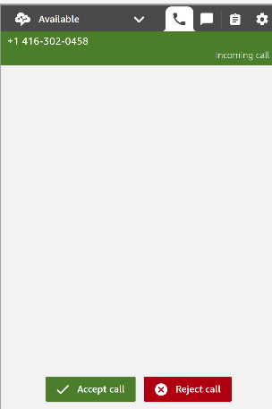

* After the test call, select Continue to navigate to the dashboard page.
* Select Test chat.

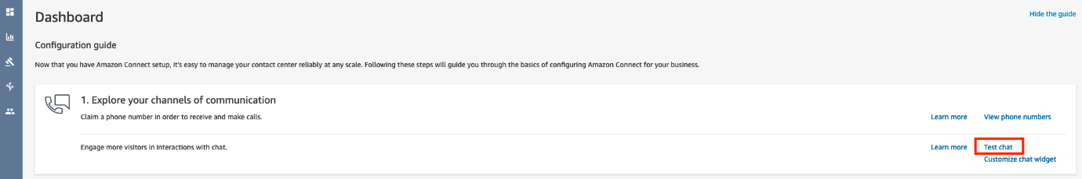

* Perform the test chat:
  + Select Activate the Contact Control Panel. Note:

*You may be asked to provide microphone/camera access.*

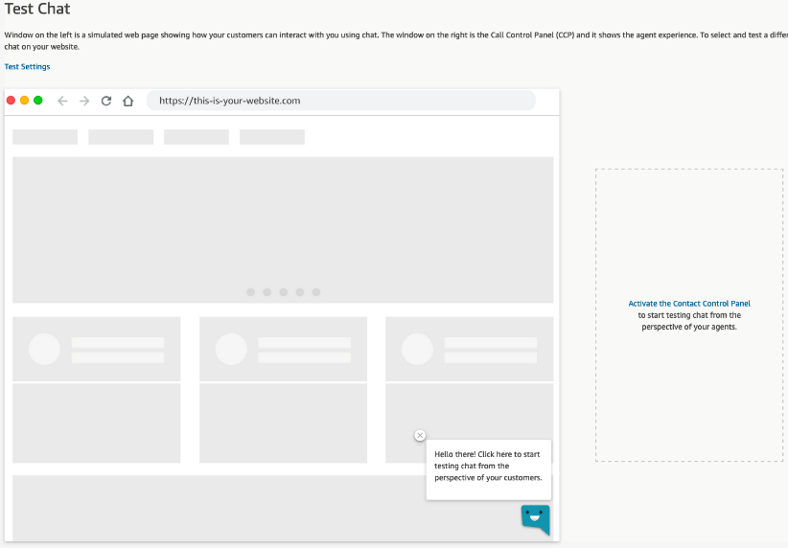

* Click ‘Activate the ‘contact center panel.’
* Choose ‘Available’.

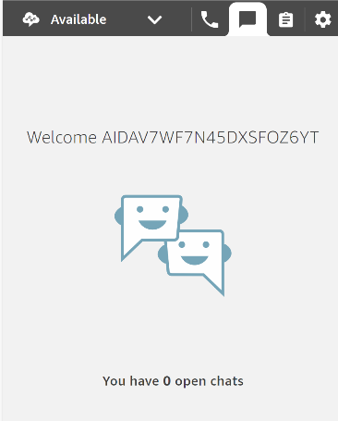

* Select the chat icon on the simulated web page to start the conversation as a customer.

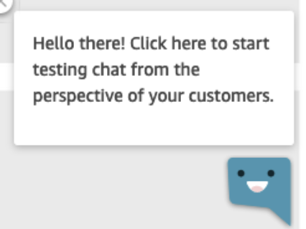

* Wait a moment and the welcome message will be displayed, followed by a queue message, then a connection message.
* Accept the chat in the CCP. You will see the current transcript.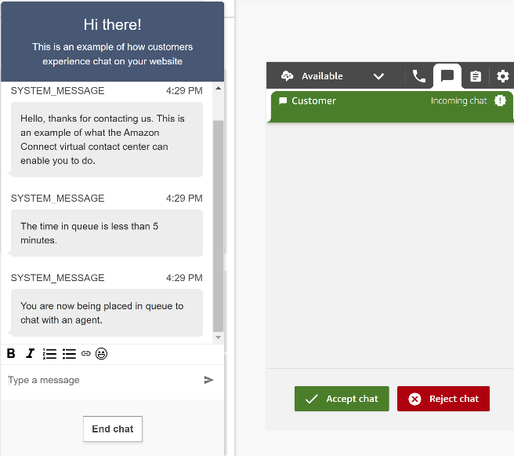
* Type a message from each side. Note the typing indicator.

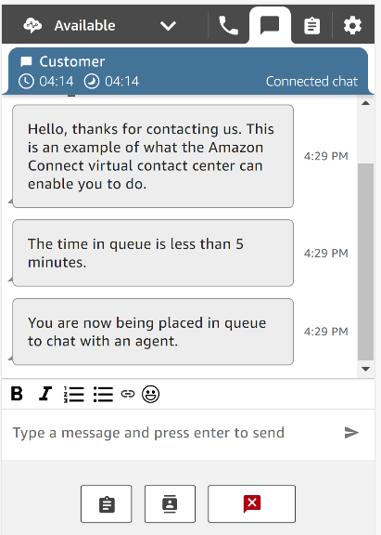

* End the chat from the customer side.
* Close the contact from the agent side.

### Amazon Connect UI Overview

* Left side is the **Navigation Menu**, which provides access to the different elements you can configure.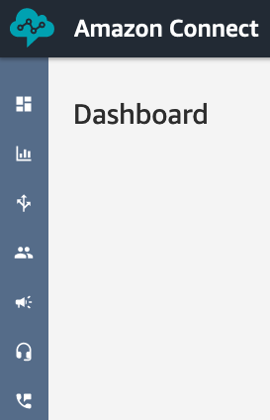
* Top right provides access to:



* Username – who is currently logged in.
* Exit Icon – Log out of Amazon Connect administrator.
* Question mark – Provides link to the documentation.
* Language selection – Changes the language for the UI. *This DOES NOT change the language of the contact center.*
* Phone Icon - Contact Control Panel – Provides access to the CCP as the currently logged in user.
* Agent Workspace - Provide access to the Agent Workspace as the currently logged in user.

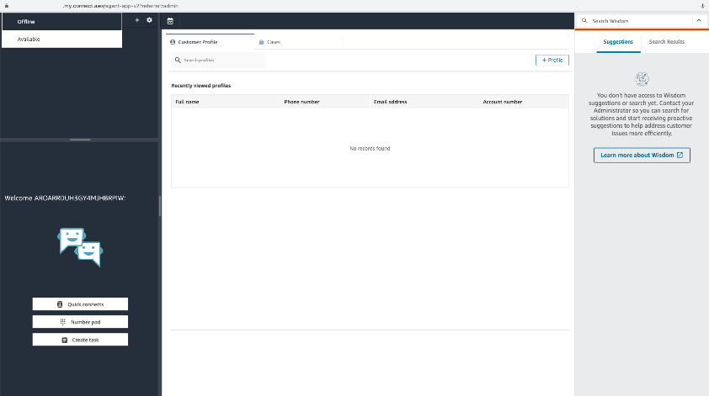

* Main pane – where all configuration elements will be presented.
* Amazon Connect Icon – Provides a quick link back to the main page, which will either be the deployment guide or dashboard.

### Introduction to Flows.

* Creating a simple flow.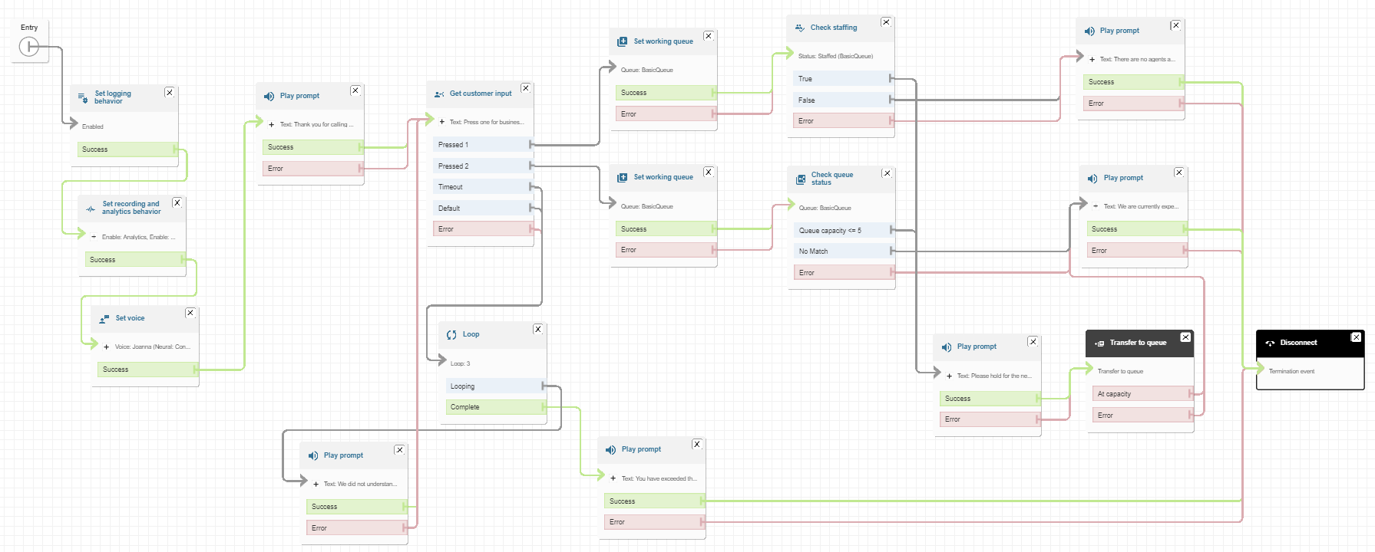
* Step 1 – Create Flow (inbound)
  + Select **Routing -> Flows** to access the contact flows library.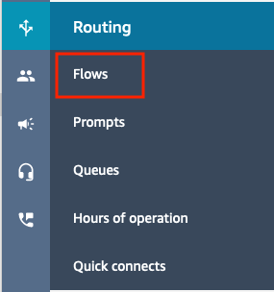
  + Select **Create Flow**Image2.4
  + Provide a name for the flow, **Intro Flow 1**
  + Expand the flow info by choosing **Show additional flow information** and provide a description. The description can be useful when looking at different versions of a flow.
  + Collapse the additional info section.
  + Select **Save**.

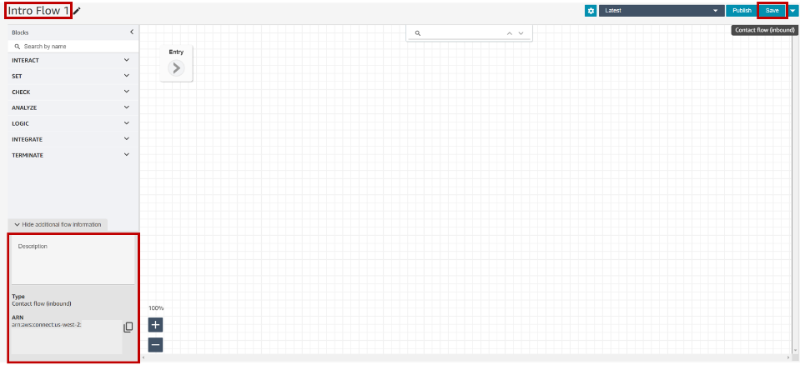

* Step 2 – Add and connect flow blocks & Save/Publish contact flow history.
  + From TERMINATE, add a Disconnect block to the contact flow, placing it on the far right of the visible screen.
  + Connect the Entry point to the Disconnect block
  + Select Publish. Now the contact flow saved successfully. Drop down the version tree to see the previously saved version and the new published version listed.

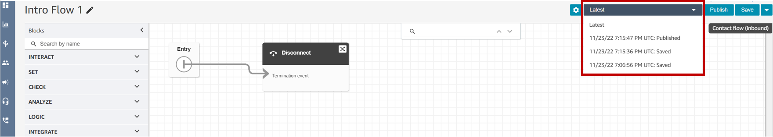

xczc

* Step 3 – Set Logging, Recording, and Voice
  + Update the contact flow to be a more complete first example.
  + Remove the link between the two blocks.
  + From **ANALYZE**, add a **Set Logging Behavior** and **Set Recording and Analytics behavior** blocks to the workspace.
  + From **SET**, add a **Set Voice** block to the workspace.
  + Connect the **Entry** point block Start branch to the **Set logging behavior** block.
  + Connect the Set **logging behavior** block **Success** branch to the **Set recording and Analytics behavior** blocks.
  + Modify the **Set recording and analytics** behavior block as flows:
    - Call recording: select radio button for **On.**
    - Select radio button for **Agent and Customer.**
    - Under **Analytics**, select radio button for **On** and place a check mark in the **Enable speech analytics** box.
    - Select the radio button for **Real-time and post-call analytics.**
    - **Save.**

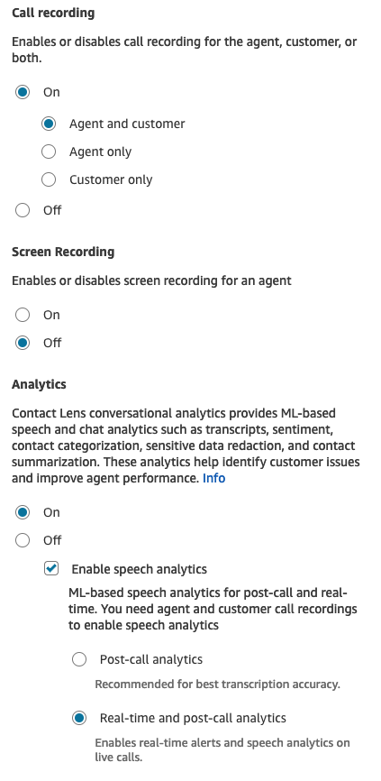

* + Connect the Set recording and Analytics behavior block Success branch to the Set Voice block.
  + Modify the Set Voice block as flows:
    - Place a check in the box for **Override** **speaking** **style** – **Neural: Conversational.**
    - Select **Conversational** in the dropdown under Neural Speaking style.
    - **Save.**

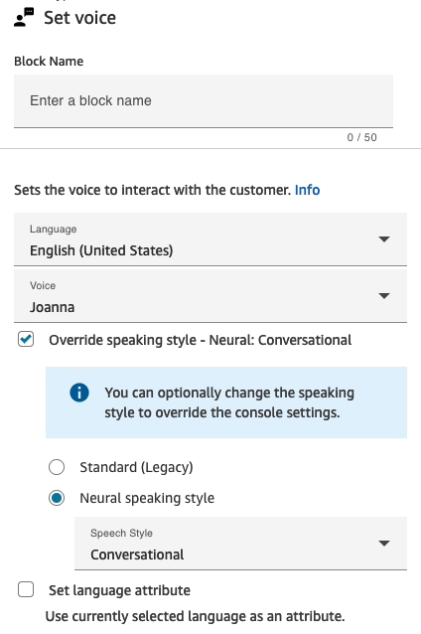

* + Select Save to save the flow.

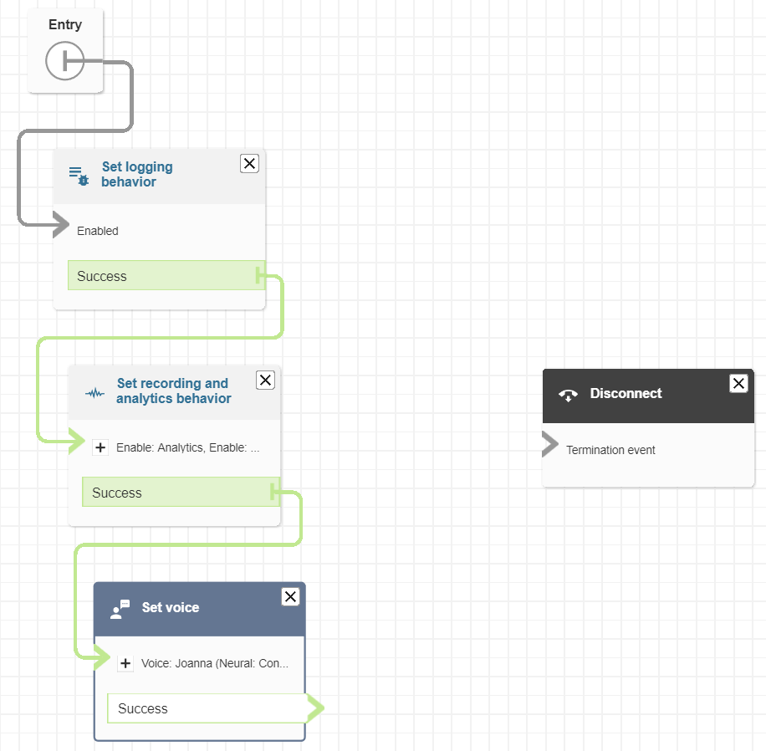

* Step 4 – Building Customer Interaction and Error Handling
  + rom **INTERACT**, add a **Play prompt** and a **Get customer** input blocks.
  + Connect the **Set** Voice block to the **Play prompt** block.
  + Modify the **Play prompt** block as follows:
    - Select **text-to-speech or chat text**.
    - In the **Enter text field**, enter: *Thank you for calling our Bank Call center managed by Amazon Connect.*
    - **Save**.

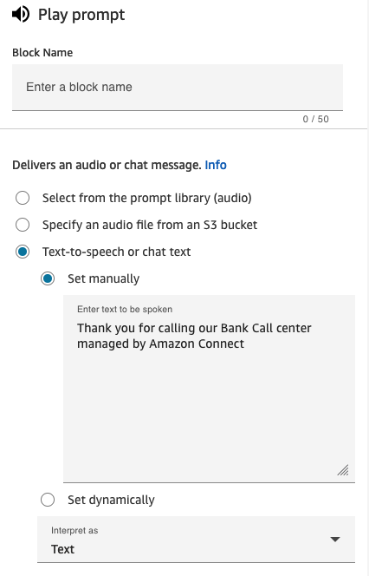

* + Connect the **Play prompt** block to the **Get customer input** block.
  + Modify the **Get customer** input block as follows:
    - Select **Text-to-speech or chat text.**
    - In the **Enter text field**, enter: *Press one for business accounts. Press two for personal accounts.*
    - In the **DTMF** section, select **Add another** **condition** twice. Set the options to **1** and **2.**
    - **Save.**

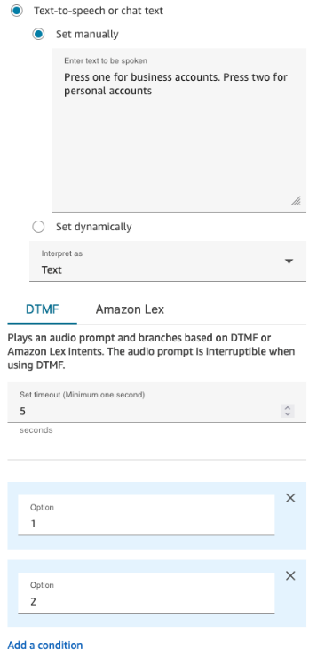

* + From **SET**, drag two **Set working queue** blocks to the right of your Get customer input block.
  + Open the first **Set working queue** block.
    - Select the radio button **By queue.**
    - Select the **Search for queue** dropdown.
    - Select **BasicQueue**, since it is the only queue in the system at this point.
    - Select **Save.**
    - Repeat this Step 5.7 Item 1 through 4 for the second **Set working queue** block.
  + From the **Get customer input** block, connect the **Pressed 1** branch to one of the **Set working queue** blocks and the **Pressed 2** branch to the other.
  + From **LOGIC**, drag a **Loop** block beneath the Get Customer input block.
  + From **INTERACT**, drag two (2) **Play Prompt** beneath the Loop block.
  + Modify the first **Play prompt** block as follows:
    - Select **text-to-speech or chat text.**
    - In the **Enter text field**, enter: *We did not understand your entry. Let’s try again.*
    - **Save.**
  + Modify the second **Play prompt** block as follows:
    - Select **text-to-speech or chat text**
    - In the **Enter text field**, enter: *You have exceeded the maximum number of attempts. Please try again later.*
    - **Save**
  + Connect the Get Customer Input block - **Timeout, Default** and **Error** branches to the **Loop** block.
  + Connect the Loop block **Looping** branch to the Play Prompt block that states, *“We did not understand your entry. Let’s try again.”*
  + Connect the Loop block **Complete** branch to the Play Prompt block that states: *You have exceeded the maximum number of attempts. Please try again later.*
  + Connect the **Play Prompt** block that states: *You have exceeded the maximum number of attempts. Please try again later*. **Success** and **Error** branch to the **Disconnect** block.
  + Connect the **Play Prompt** block that states: *We did not understand your entry. Let’s try again*. **Success** and **Error** branch to the **Get Customer** Input block.

This ends our error handling branch.

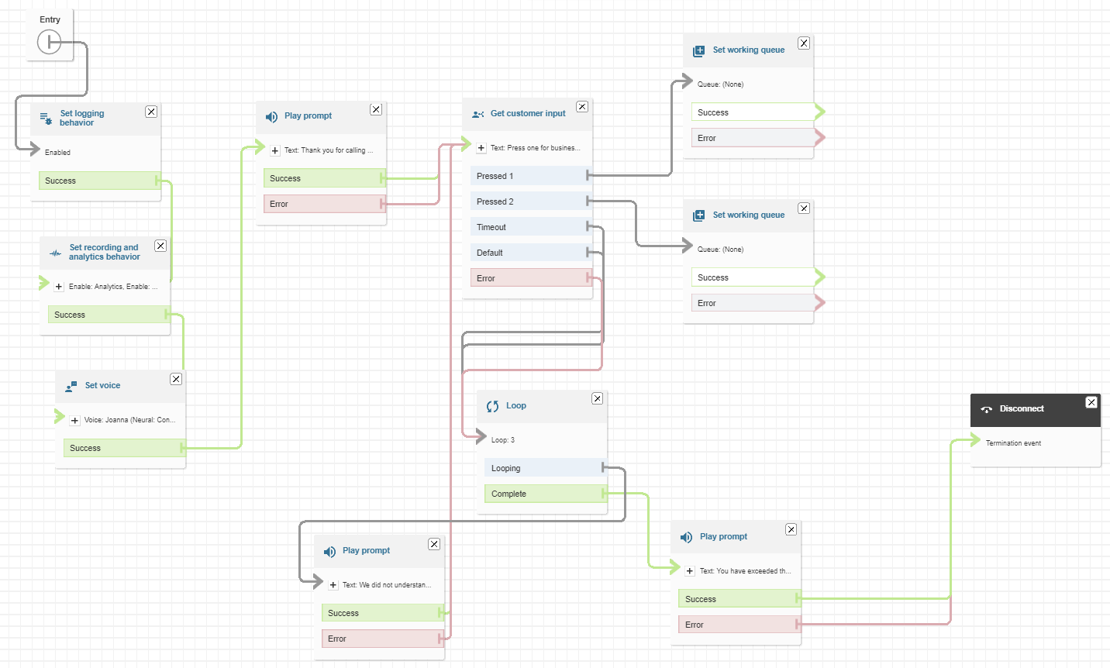

* + - * 1. **Cost Analysis**

# Conclusion

In conclusion, the implementation of the GroupOne Call Center project using Amazon Connect and AWS has successfully transformed and elevated our customer service capabilities at the bank. The project objectives were carefully designed to enhance call handling efficiency, ensure quality through call recordings, provide a seamless voice response system, empower agents with advanced tools, enable integrations for enhanced functionality, and establish robust monitoring and security measures.

The introduction of call forwarding and a call-back choice has notably improved the speed and accuracy with which calls are directed to the right agents. This enhancement ensures that our customers experience a smoother and more efficient interaction with our call center services.

The incorporation of Amazon Lex and Lambda integrations has enabled us to implement serverless functions during contact flows, offering customers chat responses that contribute to a more versatile and responsive customer engagement platform.

Our commitment to quality is reflected in the implementation of call recordings, allowing for continuous improvement through data analysis. The real-time monitoring capabilities ensure that our contact center performance is consistently optimized.

The emphasis on security measures, including access control for users and administrators, underscores our dedication to protecting customer information and ensuring a secure environment for all interactions.

The GroupOne Call Center project has successfully achieved its objectives, providing our agents with superior tools to assist customers effectively. This, in turn, has contributed to an overall improvement in customer satisfaction and reinforces our commitment to delivering top-notch banking services.

As we move forward, we will continue to leverage Amazon Connect and AWS technologies to adapt and enhance our call center services, staying at the forefront of innovation in customer service within the banking industry.

Appendices:

Lab Material:

<https://catalog.us-east-1.prod.workshops.aws/workshops/d1f03aa4-9605-4925-aa18-e82819feb069/en-US>